#times child hits note ( y) | 15 | 16 | 21 | 32 | 10 | 40
#of minutes of piano per week( x) | 30 | 45 | 30 | 60 | 30 | 90

Correlation
x-x̄ | y-ȳ | (x-x̄)2 | (y-ȳ)2 | (x-x̄)(y-ȳ)
17.5 | -7.3333 | 306.25 | 306.25 | 128.3333
-2.5 | -6.3333 | 6.25 | 6.25 | 15.8333
-17.5 | -1.3333 | 306.25 | 306.25 | 23.3333
12.5 | 9.6667 | 156.25 | 156.25 | 120.8333
-17.5 | -12.3333 | 306.25 | 306.25 | 215.8333
42.5 | 17.6667 | 1806.25 | 1806.25 | 750.8333
0 |  | 2887.5(SSx) | 653.3333 (SSy) | 1255 (SPxy

r = Σ(xi - x̄)(yi - ȳ)/√(Σ( xi - x̄)2Σ(yi - ȳ)2 )
r =1255/√(2887.5*653.3333
= 0.9137
Since the correlation coefficient is greater than 0.5 and is positive, there is a high positive correlation between the #times child hits note and #of minutes of piano per week.

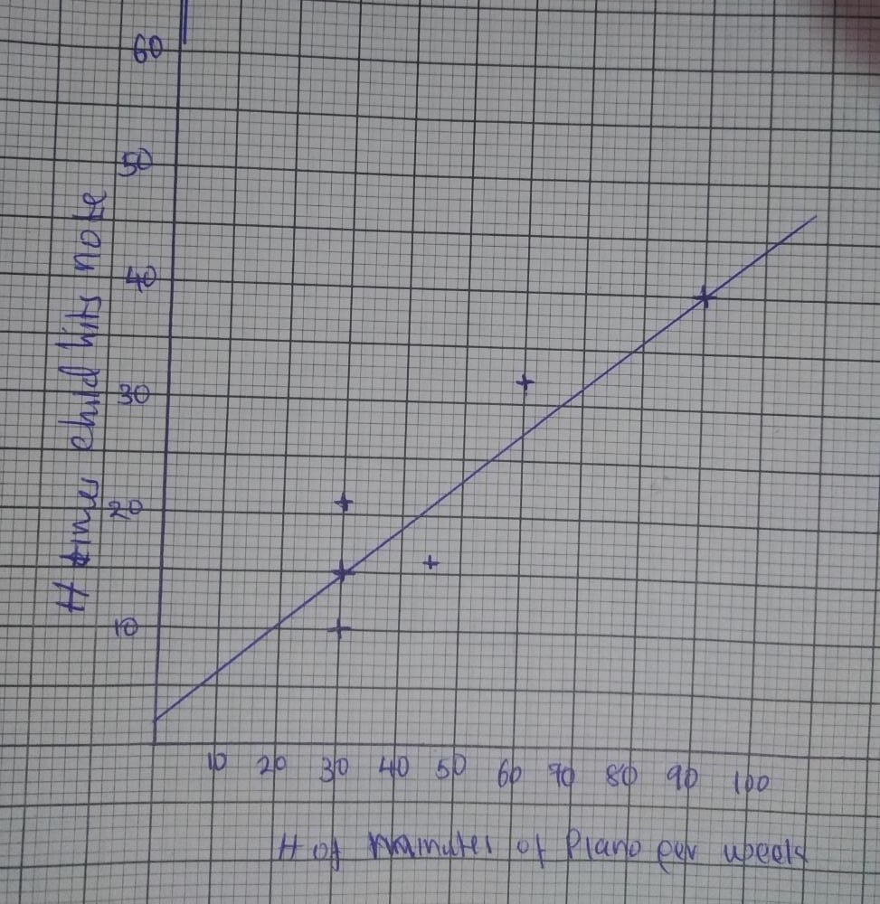
Slope = (40-15)/90-30
= 0.417
The intercept is 2.
The equation is y = 0.417x+2
The point on the best point on the line that demonstrates that the regression equation represents the best fitted line in the data is (30,15).

